Literacy and English  Comprehension - Watch the trailer for Finding Nemo  https://www.youtube.com/watch?v=wZdpNglLbt8  discuss these questions with an grown up.  Why was Nemo’s Dad upset?  How many different sea creatures did you spot?  Do you think Nemo was in danger? Why?  Does the trailer make you want to watch the film? Why? | Maths and Numeracy  Shape 2D and 3D  Play ‘Guess the shape’. Describe a shape, remembering to say how many sides and corners. Can you spot any 2D and 3D shapes around you? What places, animals or objects can you draw using only 2D shapes? | Health and Well Being  Friendship - Nemo had lots of friends who looked out for him. Draw a picture of all of your friends and talk about the other people in your back up team.  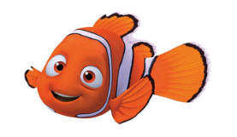
Literacy and English  Diagram - Draw a picture of a fish and label its parts  tail fin head gills  eyes mouth  Can you find out any other facts about fish? | Maths and Numeracy  Practice counting forwards and backwards to 20 stopping and starting at different points.  Practice the number before and the number after.  https://www.topmarks.co.uk/ordering-and-sequencing/caterpillar-ordering | STEM  Floating and Sinking – ask an adult to help you fill a basin or bowl with water. Find items around the house and test to see if they float or sink. Make a guess first before you try. This is called an estimate. Were there any surprises?
Literacy and English  Word-building -How many words can you make with these letters? Use magnetic letters, foam letters or cards with the letter on.  t a p r i s n e m  map pan sip | Maths and Numeracy  Spotting Numbers – Have a look inside and outside and see how many numbers you can spot. How many numbers you can say? How many can you write?  1 2 3 4 5 6 7 8 9 10 | Expressive Arts  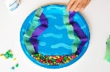  Design some plants and animals that you would find under the sea, Cut them out and stick them in a bowl, paper plate or a jar as a home for a fish. Design and make a fish to live in it.  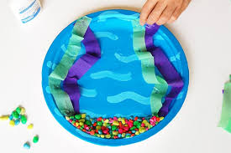
Literacy and English  Sentences  Think of a sentence that contains the words…  pin, sat, nip, nap, pan, pat. Say the sentence out loud. Can you make a funny story using some of these words? Eg I sat on the beach and a crab decided to nip my toes. | Maths and Numeracy  Length -  Collect as many objects as you can that are longer than your thumb.  Collect as many objects that are shorter than your sock.  Which item is the longest? Which is the shortest? | Social Studies  Keeping Safe on the road – practice with an adult the rules for crossing the road safely. Remember to  Stop, Think, Look, Listen!
Literacy and English  Reading - Choose your favourite story and ask a grown up to read it to you. Can you find any tricky words you know? Draw a picture of your favourite character and talk about what you like about them. | 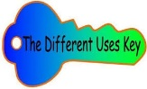  Problem Solving  Different Uses Thinking Key  How many different uses can you think of for a goldfish bowl? | Health and Well Being  Scavenger Hunt – Go outside for a walk or to the park and try and collect these items:  Pine cone, white stone, black stone, bark, fallen apple, piece of wood, fallen leaves, twig, acorn, sycamore key

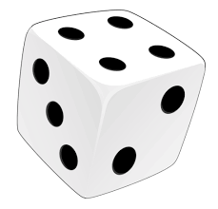
Self-reflection Plenary
At the end of a day of learning you might like to choose a row (A, B or C) and roll a die to select some self-reflection questions. You can Look at them by yourself or, even better, discuss them with someone else.
 | 1 | 2 | 3 | 4 | 5 | 6
A | Were there any tasks today that I found too easy? Why? Could I have added my own challenge? | Were there any tasks today that I found too difficult? What made it difficult? Did I give up straight away or keep trying? | Did I estimate correctly how long each task would take? If not did I under estimate or over estimate? | Did I start with the easiest bits of the task or the hardest? Did I work through tasks in a specific order? | Did I try going back to a tricky task later and reading it again? Did it make a difference? | Did any of yesterday’s tasks make more sense today now that my brain has had time away from it?
B | Which parts of today’s tasks used knowledge I felt confident about remembering? | Which tasks had new learning in them? What did I learn? | Thinking of one of my tasks. Did I understand the concept that I was working on? | Did I find it easy to stay on task today? What helped/hindered this? Is it different depending on the task? | Can I think of ways to improve my motivation for tomorrow? | Do I need to practise anything to make tomorrow’s learning easier?
C | Did I have everything I needed to complete the tasks? Did I use anything to help me? | Did I get stuck? How did I get past that? Did I give up or try something else? What did I try? | What made my learning stick today? What did I do that helped me understand a particular task? | How can I make sure I remember what I learned? What have I done in the past that has worked? | How long do I think I will remember what I learned? How could I check next week, next month? | Am I worried about anything after today’s work? What can do if I am worried?

